

ITA0330-Mobile Computing

Name: T. Dharani Devi Reg no:192425036

Slot: D Course Name: Mobile Computing

Experiment 9: GSM Service User Interface Prototype
Aim: To develop a user interface prototype for a GSM service using Figma.
Procedure:
- Open Figma and create a new design file.
- Select a smartphone frame for the GSM application.
- Design a home screen showing the SIM and network status.
- Add voice call, SMS, and contact management options.
- Include signal strength and network registration indicators.
- Apply suitable colors, icons, and fonts to improve usability.
- Connect the screens using Prototype mode and test the navigation.

Output:
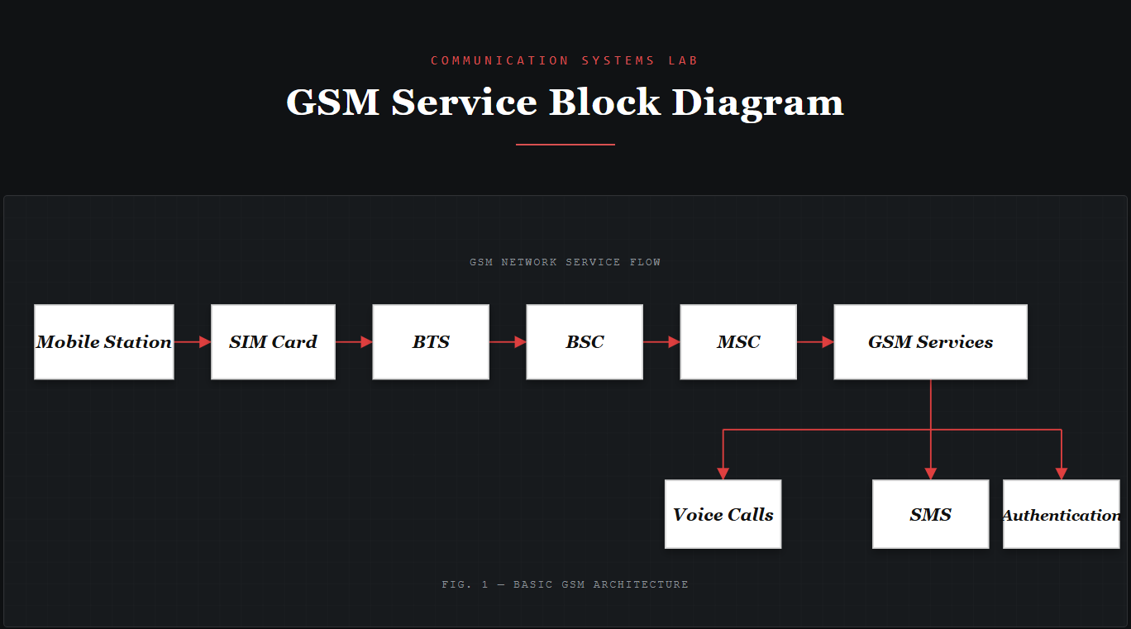
https://www.figma.com/make/nNB7Kz5By1IfyaceuqctMD/EXPERIMENT-9?t=q4ehJPQngmonsvrw-0
Result: Thus, a GSM service user interface prototype was developed successfully using Figma.

